**User journey scenarios**

Jumping right into sketching interfaces or wireframing means that you’d miss an opportunity to find delightful experiences, delightful features that will help users accomplish their tasks easily. Mapping out the user journey will help you define the customer experience of your design from start to end. *A user journey could be defined as a map of the actions and emotions that your user experiences while using your designs from start to finish.* User journeys come under many names, such as Customer Journey, Journey Map, Experience Map; everyone has a different name for it. *User Journeys define the motivations for using your app, they define the problems that your app solves for the user, they define the different phases of your app, and they define the experience from start to finish, as well as emotions and feelings that the user may have along the way.*

**A Journey Map** will help you plot out your Journey. You’ll see the different stages, and along each way for each state, you can specify the user goals, as well as details and perhaps something about the environment, and maybe what’s going through the user’s mind along the way, as well as their emotions. If any ideas come to you as you’re mapping this out, feel free to write them. Just make this as realistic as possible.

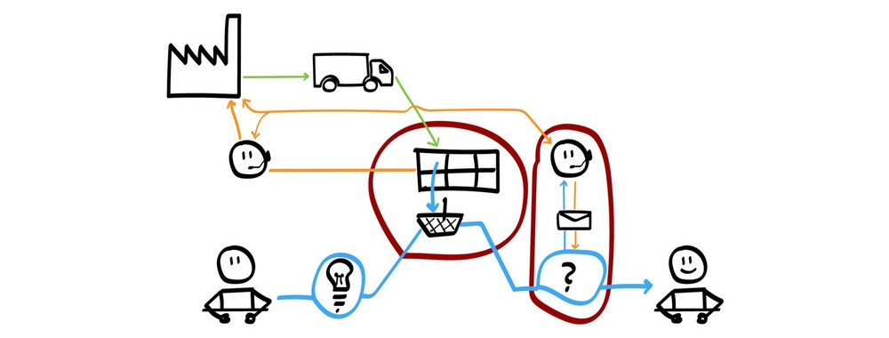

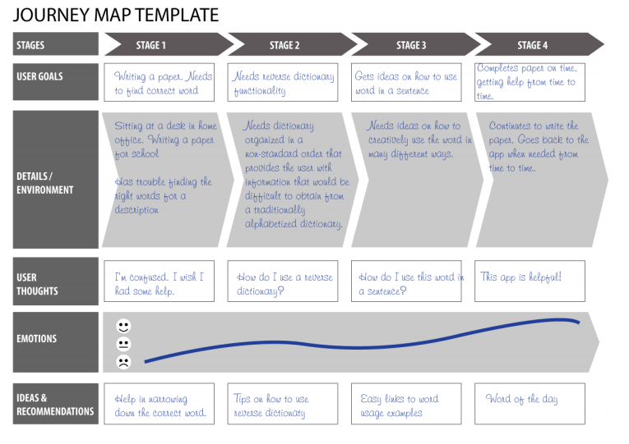

reference: https://medium.com/codingurukul/user-journey-scenarios-storyboards-and-flows-understanding-your-users-f98c8ff871f3